

Group Risk and Assurance

Risk Suite and Tracker Business User Guide

Version 1: Issued Oct 2008

Contents
I. Introduction 1
1. Overview of Data Structures 1
2. Overview of Access Control 2
3. How to Access the System 2
4. Help Facilities and System Support 2
II. Risk Suite 3
1. Risk Suite Summary Page 3
2. Accessing Risk Profiles and Risks 4
3. Creating New Risks 6
4. Editing Risks 6
5. Deleting/Archiving Risks 7
6. Accuracy of Data 8
7. Reporting 8
III. Tracker 9
1. Access to the System 9
2. Start Page 9
3. Loading Issues 10
4. Issues Page 10
5. Updating Issues and e-mail Notifications 10
6. Review Updates and Closing Issues 11
7. Deleting/Archiving Risks 11
8. Reporting 12
IV. Business Performance Reporting 13

Introduction
This document should be read in conjunction with the Group Risk Management Policy.
Risk Suite and Tracker is an intranet based IT system which supports the Group’s Risk Management and issues tracking processes. Risk Suite is used to record and monitor the main inherent risks that are managed on a day to day basis by the management team as a whole.
The system holds a series of risk libraries which record the relative status of each risk along with the owners of these risks. Controls which are designed to manage these risks are also recorded. The risk scores allocated against each risk reflect their relative importance having considered the effectiveness of the controls which are designed to manage those risks.
Risk owners, as recorded on each risk, are responsible for ensuring that risk information is maintaining up to date, aligning to reporting periods.
The Risk Management, internal audit and external audit processes generate issues which need to be managed. These are allocated an owner, relative priority and a due date and are then loaded by the Group Risk and Assurance Manager to the Tracker system. This is also an intranet based system and contains automated workflow, sending reminder e-mails to the owners of issues, who are responsible for posting timely status updates to the system.
The Group Risk and Assurance Manager is responsible for oversight of the system, including granting access to the system and data. They are also responsible for stakeholder reporting as part of overall business reporting, based upon the updates posted to Risk Suite and Tracker.

Overview of Data Structures
It is important to ensure that risk and issues under management are allocated clear ownership. All data on the system is recorded within a hierarchy which reflects the current business structure within the Group. Figure 1 below provides details of the current data structures.

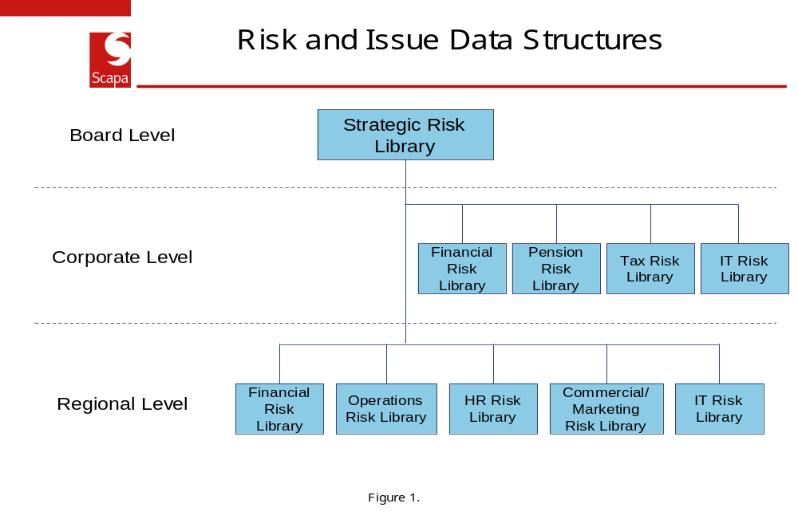
Individual risks and issues are allocated to one of the above headings.

Overview of Access Control
Access to the system is managed by the Group Risk and Assurance Manager (GRAM). All requests for access should be directed via e-mail to the GRAM.
Users will be allocated access to the system data on a “need to know” basis. For example a member of the Group Board will have access to all system data. A Europe SET member will be provided access at the Corporate level and below. A member of a site team, say focusing on Operational issues, will be given access at the regional level across the functional risk libraries.
Each user profile will be set to provide view and where required edit access. New risks can be added by reference to the GRAM. New issues will be added to the system by the GRAM. Risks which need to be removed will be deleted by the GRAM. User profiles have been created to control these areas.
Each Risk and Issue on the system is allocated a designated owner. These individuals are responsible for maintaining the status of these key forms.

How to Access the System
To access the systems you must have a valid and active user account, as maintained by the Group Risk and Assurance Manager. You will receive an e-mail when system accounts are created for you. You must change your passwords as soon as possible in both Risk Suite and Tracker. The e-mail will provide instructions.
There are two ways to access Risk Suite and Tracker:
- Access Risk Suite using the following link, http://ukdunapp003/symbiantrisksuite/LoginPage.aspx. Once you have accessed Risk Suite you can access Tracker by selecting the Tracker tab in the top menu. Provided your password in Tracker matches the one in Risk Suite you will be granted access to Tracker
- To access Tracker direct, use the following link, http://ukdunapp003/symbianttracker/LoginPage.aspx. Enter your password and userid.

Help Facilities and System Support
In addition to the guidance provided in this manual and the online tutorials (see logon pages), each screen on the system has a help option. This can be found in the top right hand corner and provides advice and guidance relating to the page you are on.
If you require other assistance specifically with Risk Suite or Tracker please contact the Group Risk Assurance Manager in Ashton on ext 7525.
Queries relating to network connections or other aspects of IT should be directed to your normal IT helpdesk.

Risk Suite
Risk Suite is used to record and monitor the main inherent risks that are managed on a day to day basis by the management team as a whole.
The system holds a series of risk libraries which record the relative status of each risk along with the owners of these risks. Controls which are designed to manage these risks are also recorded. The risk scores allocated against each risk reflect their relative importance having considered the effectiveness of the controls which are designed to manage those risks.
Risk owners, as recorded on each risk, are responsible for ensuring that risk information is maintaining up to date, reflecting the quarterly reporting process.
To access the system refer to I.4 above.

Risk Suite Summary Page
Once you have logged on to Risk Suite you will access a screen which provides a summary of all the documents in the system that you can access. An example is provided below in figure 2.
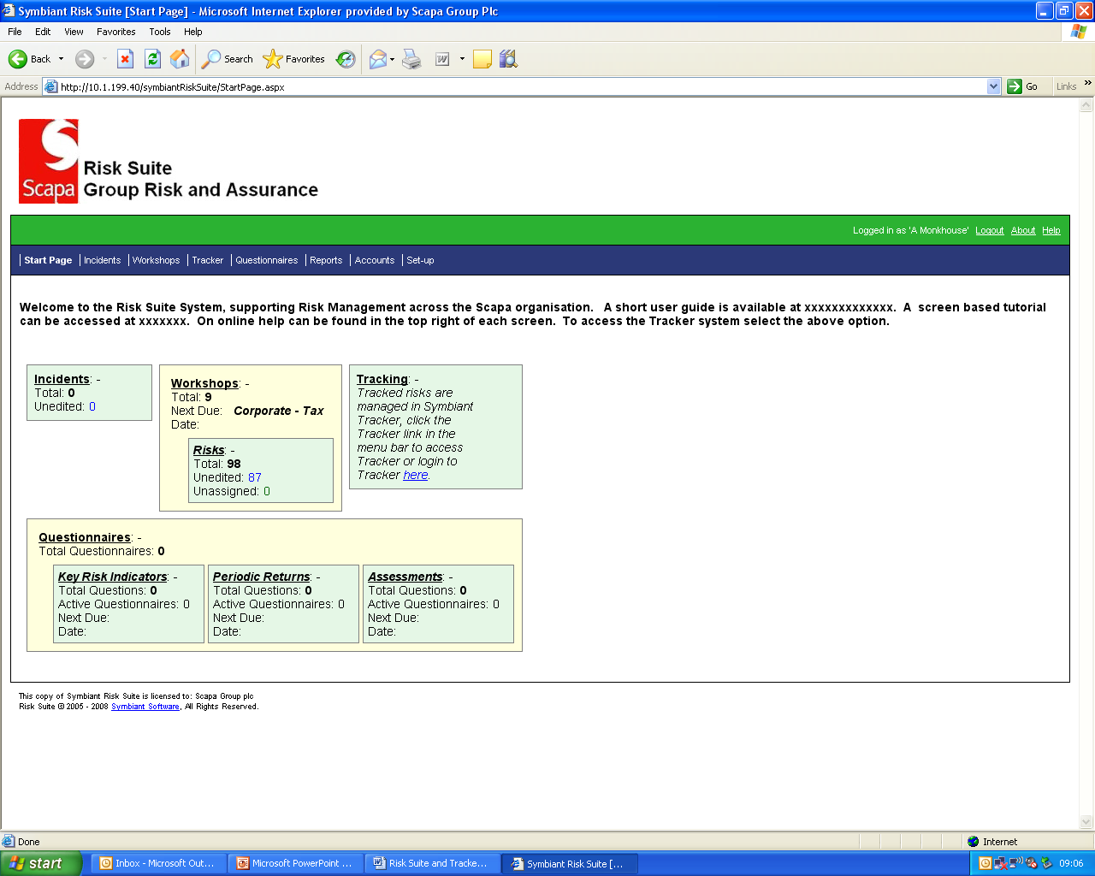
Figure 2.
The above screen provides a summary of the following:
- Incidents – not currently in use
- Workshops – the number of workshops you have access to.
- Tracker – see section III
- Reports – see 7.
- Questionnaires – not currently in use.

Accessing Risk Profiles and Risks
To access a summary of the Risk Profiles you have access to, at the summary page (Figure2) click on the Workshop tab towards the top of the page. This will then open a web page as below in figure 3.
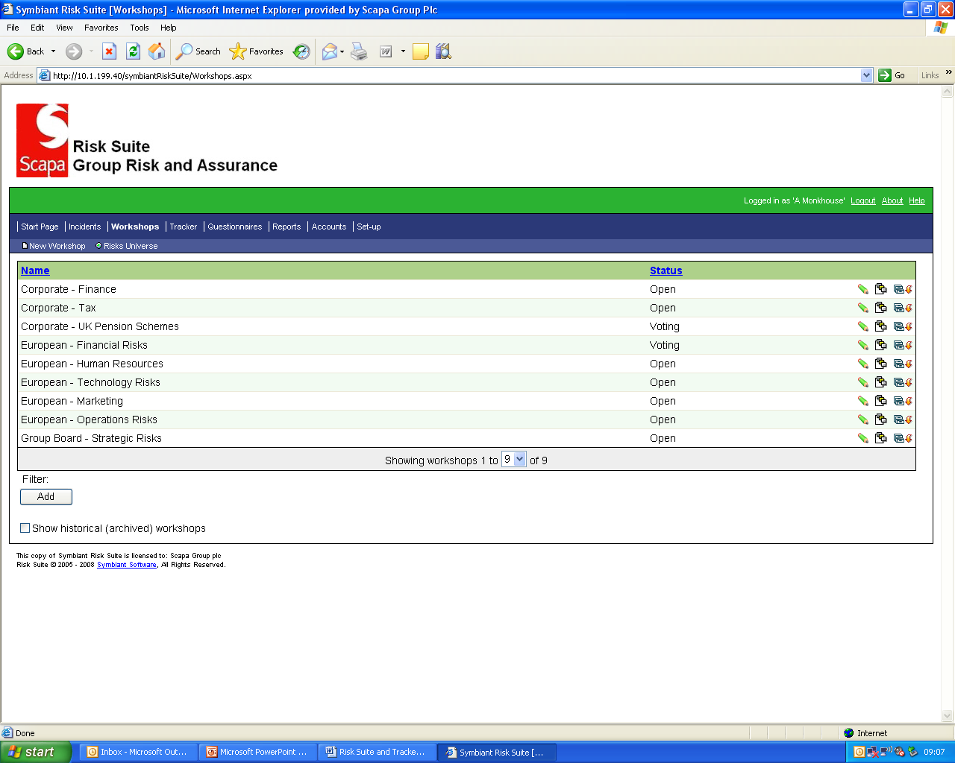
Figure 3.
The screen will list the risk libraries that you can access. By hovering the mouse over the icons to the right of the page you can perform one of the following:
- Edit the workshop – this is a summary document which the Group Risk and Assurance Manager uses to controls who can access the underlying risks.
- Access a summary of the risks within the workshop/risk library
- Archive the workshop/risk library
Note that each page is automatically limited to displaying 10 workshops. You can expand the view if there are more by clicking on the down arrow in the grey bar at the bottom of the screen.
You will only see the icons that you have access rights to, which in most cases will be the icon showing three small adjacent documents. This opens a summary of the risks within the selected workshop/library. See figure 4 below.

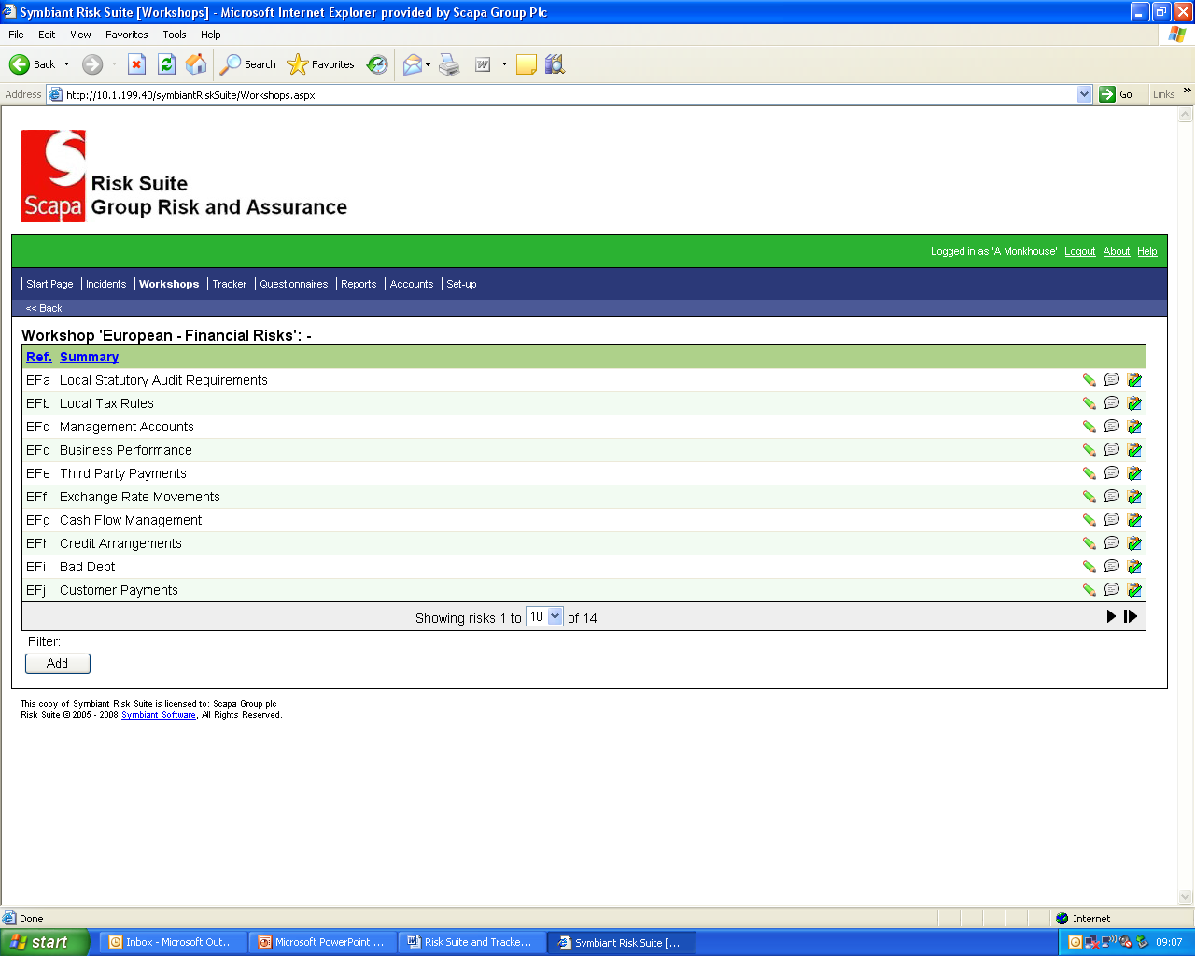
Figure 4.
The screen will list the risks within the selected workshop/risk library. By hovering the mouse over the icons to the right of the page you can perform one of the following:
- Edit the risk – see 4 below.
- Attach a document which might be relevant to the risk.
- Add comments associated with the risk.
You will only see the icons that you have access rights to, which in most cases will be the icon showing a pencil which allows edit access to the selected risk.

Filtering
Using the “Filter” and “Add” buttons (bottom right) you can apply a filter to apply to the reported risk. In the example below, figure 5, the selected filter options are returning all risk within the European Finance Risk Library owned by the specified user.
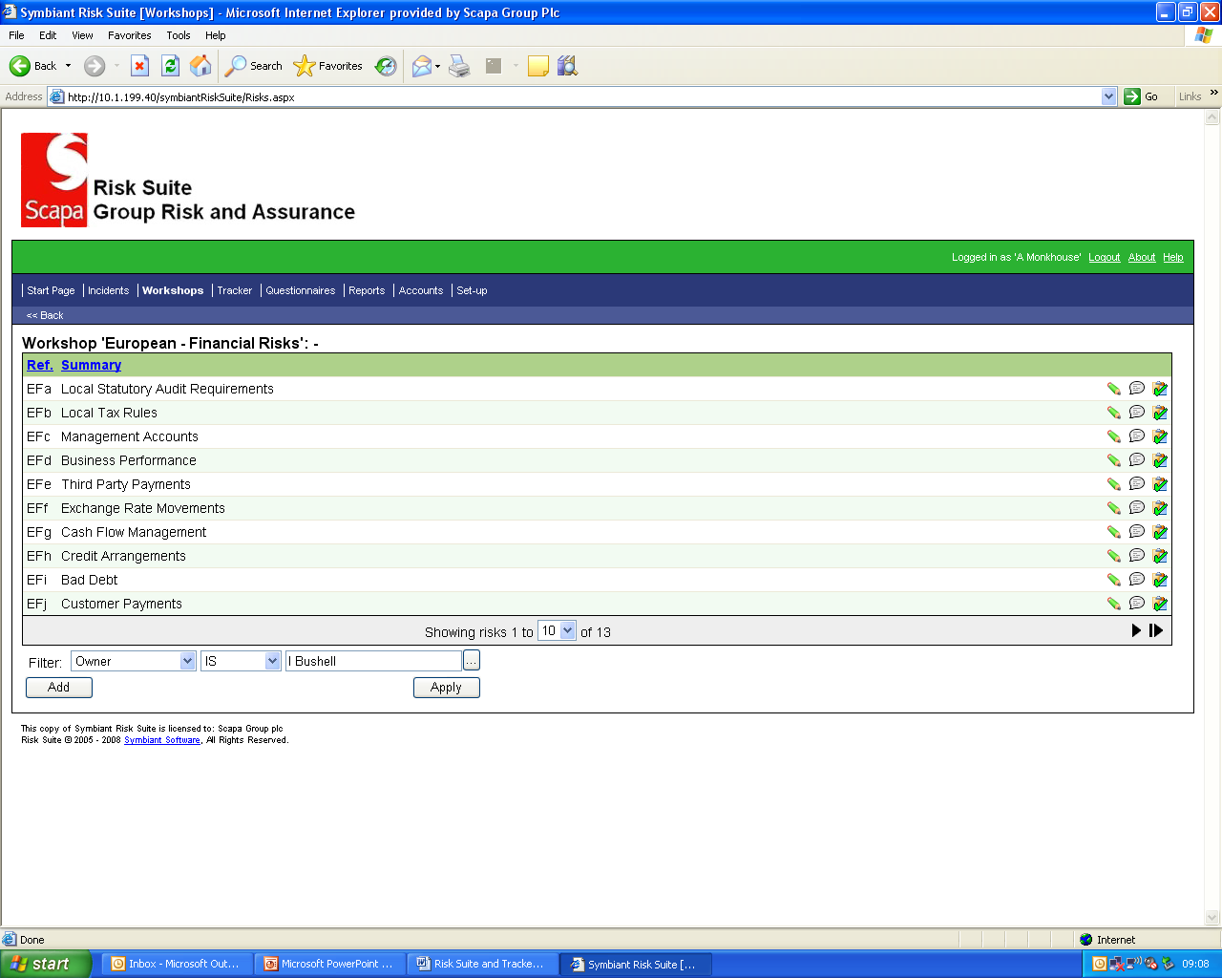
Figure 5.

Creating New Risks
New risks can only be added by the Group Risk and Assurance Manager (GRAM). Where these are required, risk owners should refer to the GRAM.

Editing Risks
Section 2 describes how to access a risk. This will display the following screen at figure 6.
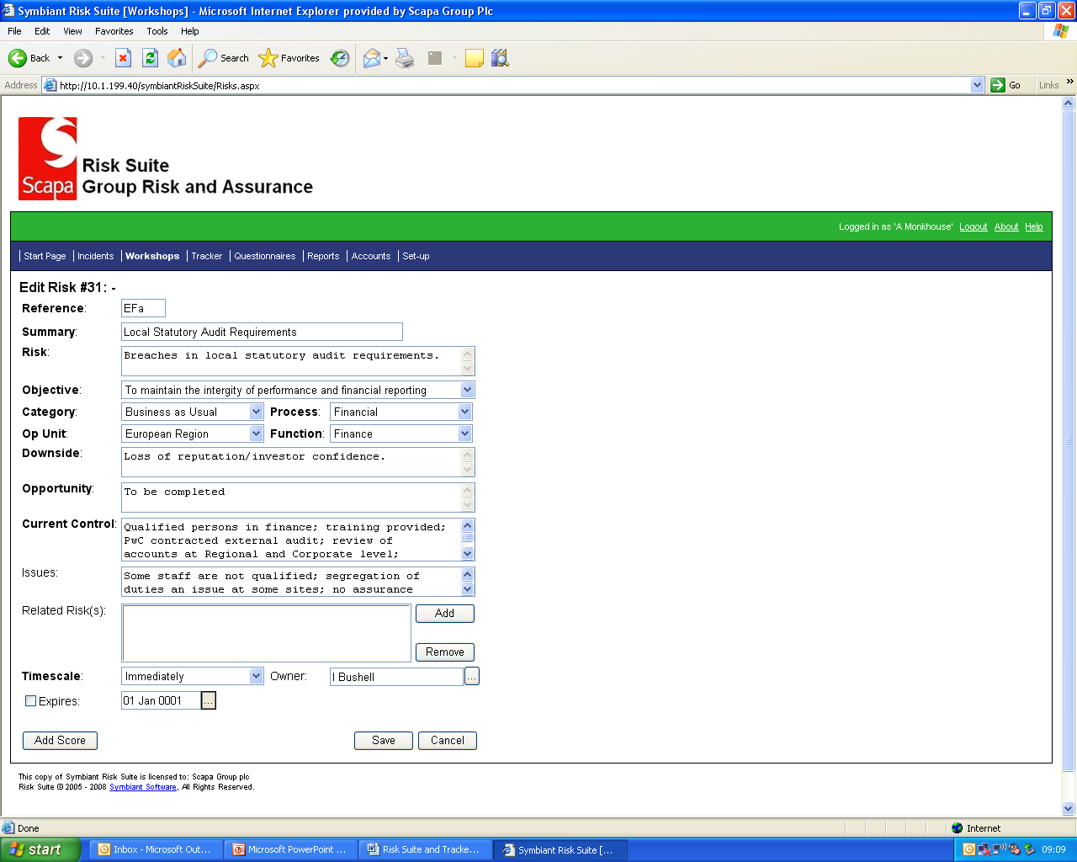
Figure 6.

Users with edit access can edit the following fields:
- Ref – a unique reference number for each risk.
- Summary – a short summary of the risk.
- Risk – a longer description of the risk.
- Objective – not currently used.
- Category – a picklist of risk types.
- Op Unit – a picklist of operations units.
- Process – a picklist of processes which usually align to the risk type above.
- Function - a picklist of functions which usually align to the process type above.
- Downside – the possible consequence should the risk materialise.
- Opportunities – the benefits of managing the risk.
- Current Controls – the controls currently in place to manage the risk.
- Issues – issues which need to be managed.
- Owner – the owner of the risk.
- Scores – the Inherent (Gross) and Residual (Net) risk scores.

Deleting/Archiving Risks
Risks can be deleted and archived by the Group Risk and Assurance Manager (GRAM). Where these are required, risk owners should refer to the GRAM.

Accuracy of Data
Quarterly reporting, as part of standard business performance reporting, is undertaken by the Group Risk and Assurance Manager. As these reports are sourced directly from the Risk Suite, it is essential that the risk profiles are maintained up to date.
For the reporting timetable refer to section IV.

Reporting
On the majority of screens there is an option on the top menu line to access “Reports”. Click on this option to access the following screen, figure 7.
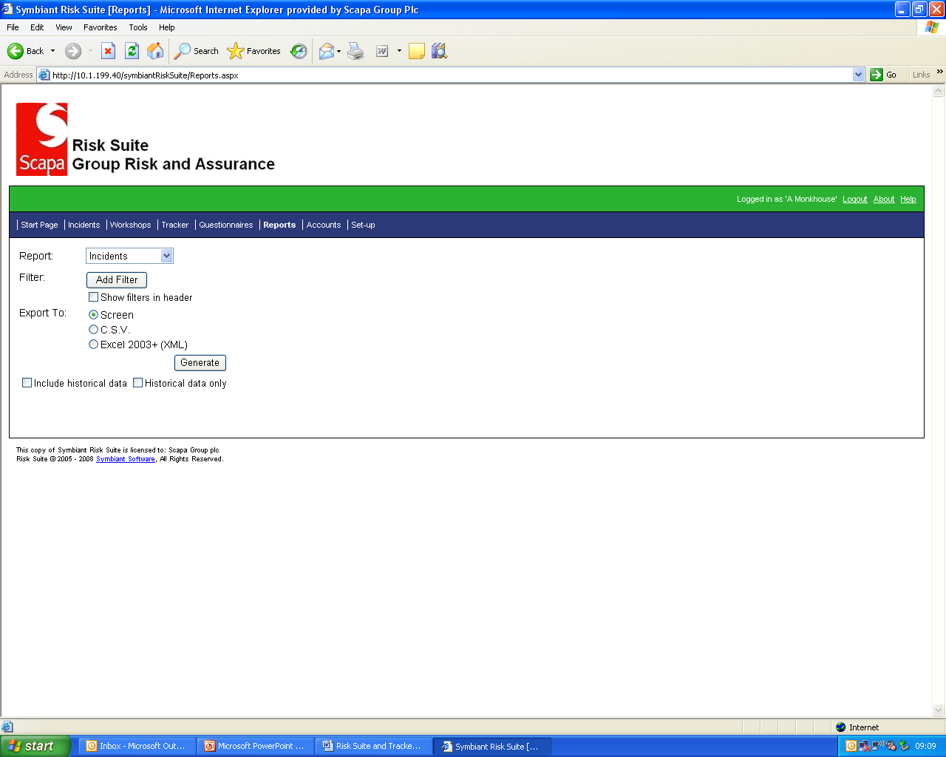
Figure 7.

Users can run predefined reports, or can build and save their own custom reports. Reports can be generated onto a screen and can be exported as a CSV or Excel file.
A full description of the reports available, together with how to build a custom report can be found under the Help option on the top right of the Reports page.
A predefined report with the title “Risk Export” under the Reports, Custom option is available which will generate a summary of all key data fields associated with the risk form. This can be filtered by for example the Owner or the Risk Workshop. You can apply a number of filters using the Filter option, before generating the report.

Tracker
The Tracker system provides authorised users with an automated tool to record and track issues arising from the Risk Management, internal audit and external audit processes.
Issues are allocated an owner, relative priority and a due date and are then loaded by the Group Risk and Assurance Manager to the Tracker system. The system is web based and contains automated workflow, sending reminder e-mails to issue owners. Issue owners are responsible for posting timely status updates to the system.
The Group Risk and Assurance Manager is responsible for oversight of the system, including granted access to the system and data. Business users can view and post updates to the system. Key status fields such as the owner, due date and status are maintained by the Group Risk and Assurance Manager based on the updates posted by the business users.

Access to the System
Refer to I.3 above.

Start Page
The Group Risk and Assurance Manager is responsible for loading issues to the system. All issues are assigned to an owner. The assigned owner is responsible for posting timely updates to the system.
After accessing the system, the system automatically loads the start page. See figure 8 below
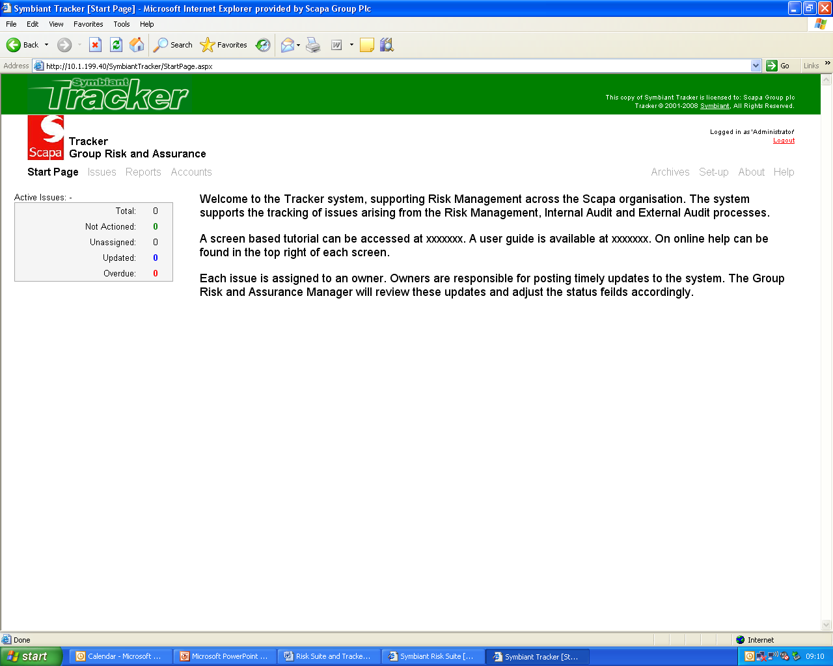
Figure 8.
In the top left of the screen the system reports the following under “Active Issues”:
- Total – all of the issues you can see irrespective of status.
- Not Actioned – shows new issues loaded where no update has been posted by the assigned owner.
- Unassigned – issues not assigned. There should not be any.
- Updated – issues which have been updated.
- Overdue – all overdue issues.
By clicking on the desired option you will access a summary page containing the issues with the selected status.

Loading Issues
All issues will be loaded to Tracker by the Group Risk and Assurance Manager.

Issues Page
At the start (figure 8) a user can select the “Issues” option. This will take you to the page at figure 9 below, which lists all of the issues a user can access.
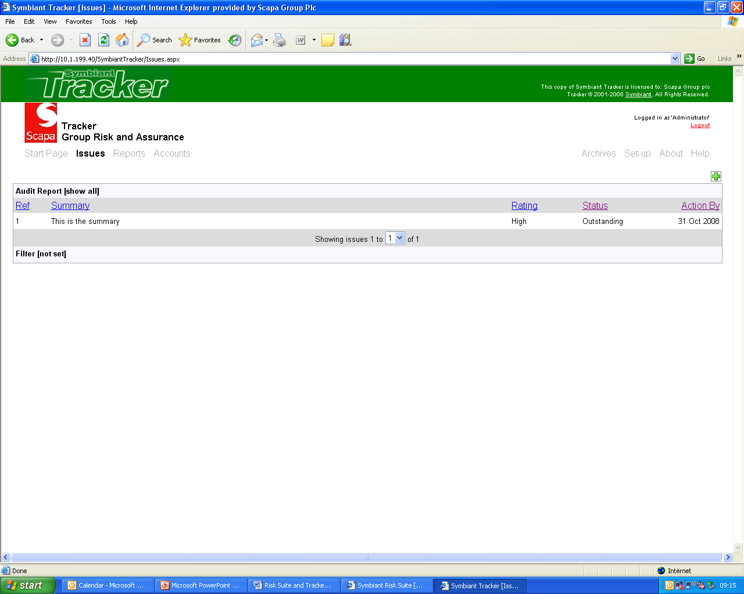
Figure 9.
At the top of the screen there is an option to filter the issues based upon the source e.g. audit report title. At the bottom of the screen there is an option to apply a more complex filter. Select the Help option for more guidance. Data can be sorted by clicking on the respective column heading.
To view an issue in detail click on the issue in question.

Updating Issues and e-mail Notifications
When an issue is loaded to the system and assigned to you, you will receive an e-mail notification. You will also receive an automated e-mail for any open issues where the due date is in two weeks time.
To update an issue select the “Not actioned” or “Issues” options. Next click on the issue required. This will open the screen at figure 10 below.
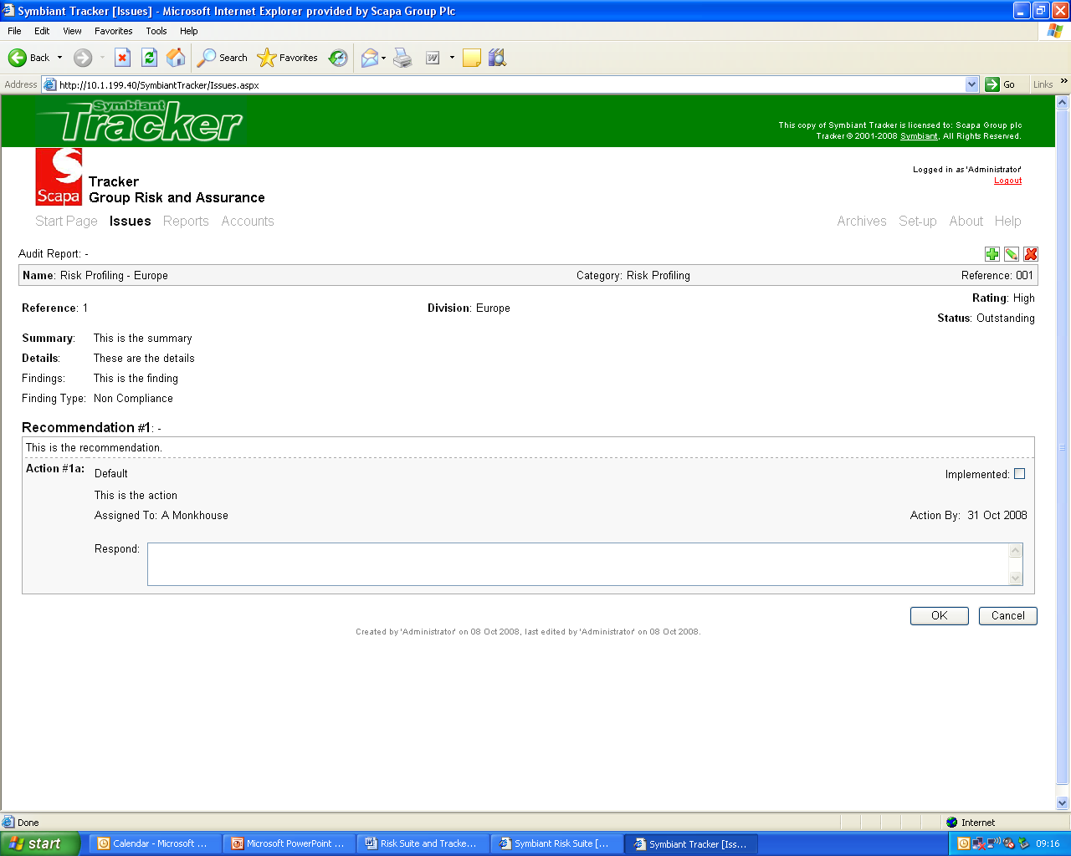
Figure 10.
Text updates can be posted in the “Response” field. Supporting documents can also be attached. Once input these must be saved using the “OK” button. The updates are then referred to the Group Risk and Assurance Manager for review.

Review Updates and Closing Issues
The Group Risk and Assurance Manager is responsible for review all updates posted to the system by the issues owners. Based on the updates they will usually perform one of the following:
- Mark the recommendation as Implemented
- Respond back to the owner with a further query – you will receive an e-mail if this occurs.
Other more rare options include selecting the “Superseded” or “No longer applicable” options where an issue has been replaced or no longer exists, for example if part of the business is sold.

Deleting/Archiving Risks
The deletion and archiving of issue data is the responsibility of the Group Risk and Assurance Manager.

Reporting
On the majority of screens there is an option on the top menu line to access “Reports”. Click on this option to access the following screen, figure 11.

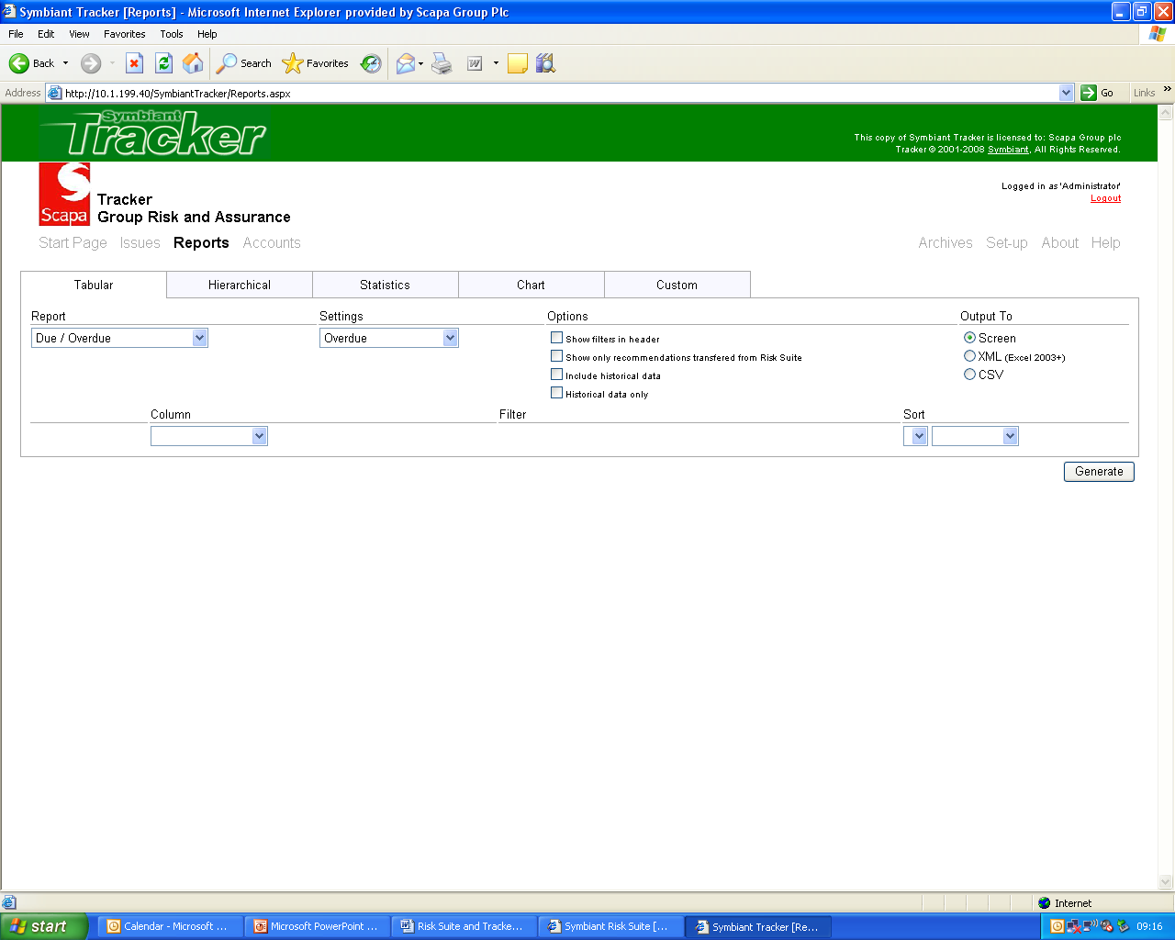
Figure 11.

Tracker can generate a variety of reports with powerful filters to display specific information. The reports are split into 5 key areas, Tabular, Hierarchical, Statistics, Charts and Custom. Select the appropriate tab and the the type of report to generate from the top left drop-down.

Business Performance Reporting
Standard templates have been developed to support reporting of the following:
- The Group’s Risk Profile
- The status of issues across the Group
Quarterly reporting, as part of standard business performance reporting, is undertaken by the Group Risk and Assurance Manager.
Two summary reports are also produced by the Group Risk and Assurance Manager for the March and November Audit Committees.
Statistics are sourced directly from the Risk Suite and Tracker Systems. It is essential that the risk profiles and status of issues are maintained up to date, particularly at the cut off dates defined below. All assigned owners of risk profiles and issues are responsible for ensuring that system data is maintained up to date to the following timetable:
- As at end of Feb – Report to March Audit Committee and Business Performance reporting
- As at end of May - Business Performance reporting
- As at end of Aug - Business Performance reporting
- As at end of Oct - Report to March Audit Committee and Business Performance reporting

